ICT ASSIGNMENT 03
Name: Shozab Haider
CMS ID: 546444
Name: Ali Arshad Malik
CMS ID: 542496
Contribution:
Ali: Part 1 and Shozab: Part 2.

Part 1
Task 1.1: Students are required to select three health or fitness applications from the Google Play Store or Apple App Store. Example apps include MyFitnessPal, Fitbit, and HealthifyMe etc. For each selected application, students should provide a detailed analysis covering its core features, strengths, weaknesses, and any other relevant observations
App 1: MyFitnessPal
App link: https://www.myfitnesspal.com/
1) Overview and Core Features
App Name: MyFitnessPal (also known as MyFitnessPal: Calorie Counter & Diet Tracker)
Developer / Company: MyFitnessPal, Inc. (founded by Mike Lee and Albert Lee)
Core Features:
- Food Logging & Large Food Database:
  - Log meals manually or via barcode scanning.
  - Includes millions of food items from global cuisines and packaged foods.
- Macronutrient & Nutrition Tracking:
  - Tracks carbs, fats, proteins, vitamins, and minerals.
  - Provides detailed nutritional breakdown for diet goals.
- Exercise / Activity Logging & App Integration:
  - Record workouts manually or sync with fitness trackers, smartwatches, and health apps.
  - Automatically adjusts calories burned.
- Water / Hydration Tracking:
  - Log daily water intake to monitor hydration.
- Weight & Progress Tracking with Charts:
  - Record weight changes and view long-term progress graphs.
- Customized Goals & Calorie Budgeting:
  - Calculates daily calorie targets based on BMR, activity level, and user goals.
  - Allows macro goals and personalized adjustments.
- Cross-Platform Sync & Integrations:
  - Syncs data across devices and integrates with various health and fitness platforms.
Platform Availability:
- Android (Google Play)
- iOS (iPhone / iPad)
- Web / Browser Version
- Wearables (Apple Watch, Wear OS devices)

2) Strengths
- Very Large Food Database: Easy logging for packaged and international foods.
- User-Friendly Interface: Simple layout suitable for beginners.
- Excellent Macro & Calorie Tracking: Supports weight loss, maintenance, and muscle gain.
Selected Positive User Feedback:

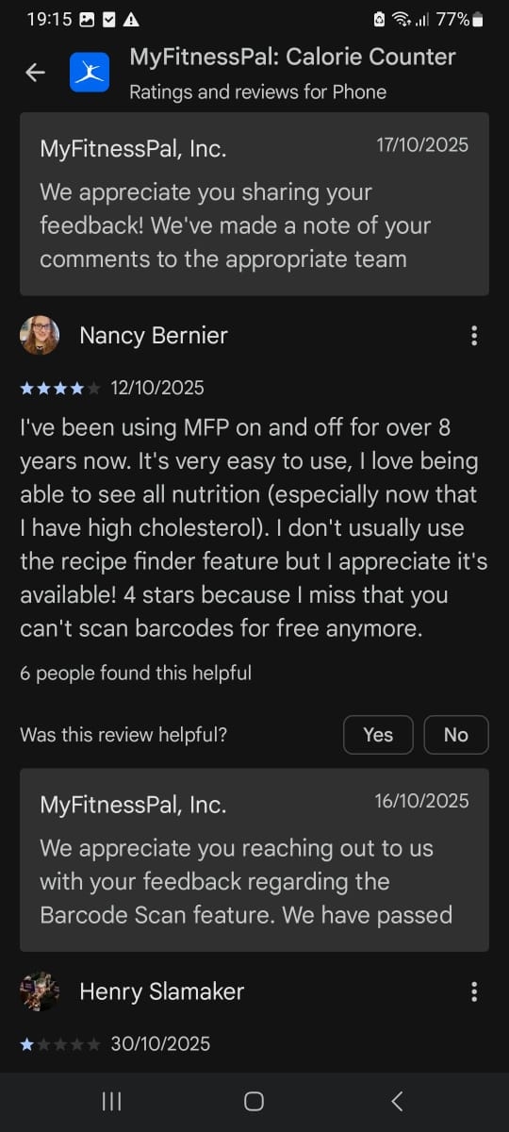
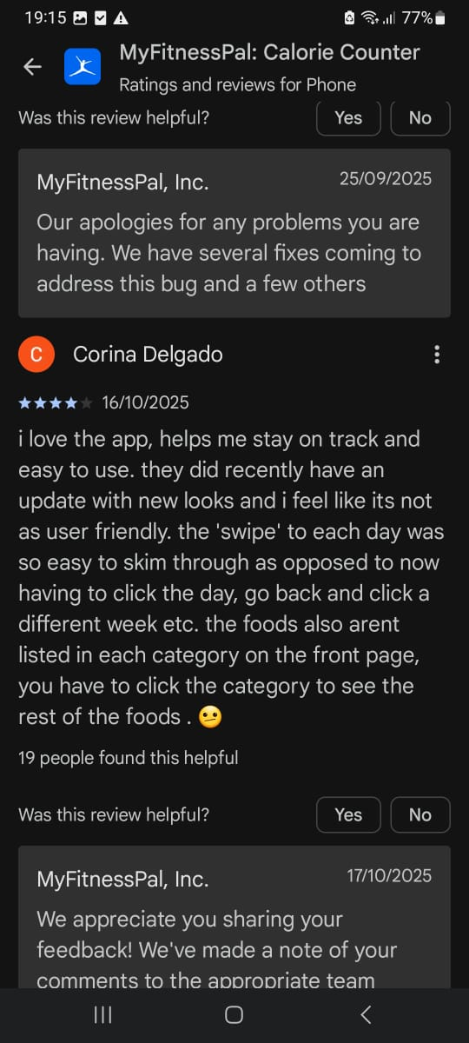

3) Weaknesses and Gaps
- Inconsistent Accuracy in Food Database: User-generated entries may be incorrect or outdated.
- Barcode Scanner Issues / Paywall Restriction: Barcode scanning now often requires Premium subscription.
- Limited Free Version: Many advanced features require Premium; free version contains ads.
Selected Negative User Feedback:
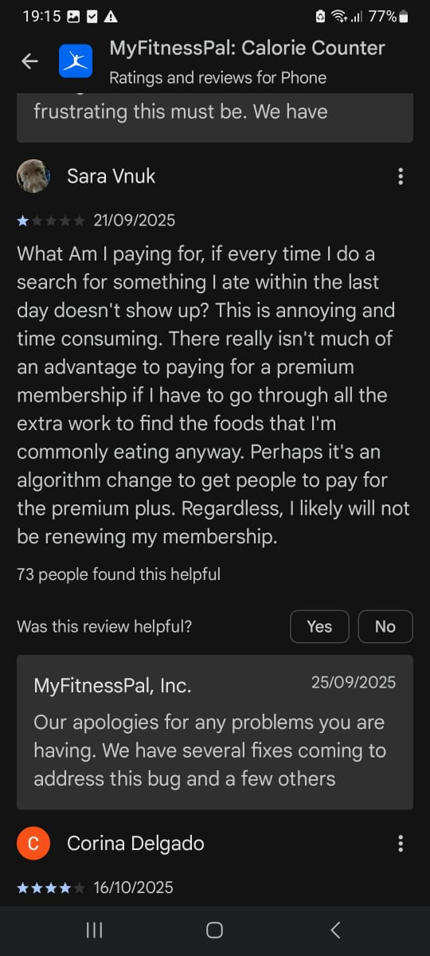
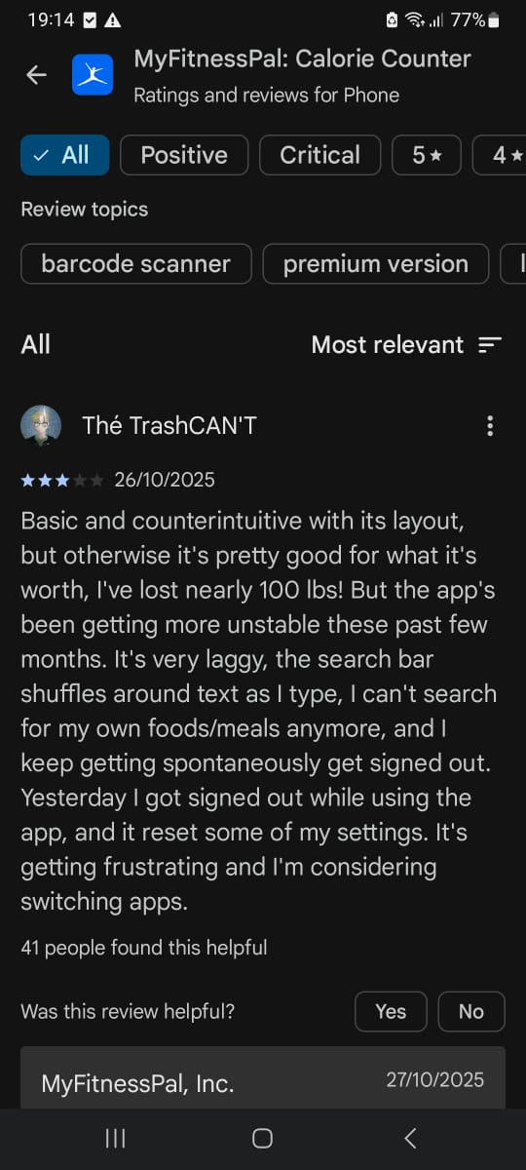

4) User Satisfaction Insights
- Android (Google Play): ~4.6 / 5 (≈1.3 million reviews)
- Trustpilot: 4.4 / 5 (8,500+ reviews)
- Third-party sites: Ratings sometimes as low as 3.3 / 5
Key Complaints:
- Downgraded free version with ads and Premium prompts.
- Poor updates affecting usability.
- Inaccurate food data for international or local dishes.

App 2: Fitbit
App link: https://dev.fitbit.com/login
1) Overview
App Name: Fitbit (used to manage and view data from Fitbit devices)
Developer / Company: Originally Fitbit, Inc.; acquired by Google in 2021
Target Audience:
- Individuals tracking activity, fitness, and health metrics (steps, workouts, heart rate, sleep).
- Health-conscious users seeking insights and accountability for exercise and sleep.
- Users preferring wearable devices or smartwatches to monitor daily lifestyle metrics.

2) Strengths
- Comprehensive Activity and Health Tracking: Tracks steps, workouts, calories, heart rate, sleep, and trends.
- Motivation & Accountability: Displays progress, encourages goal achievement, and promotes active lifestyle.
- Integration with Wearables: Seamlessly syncs with Fitbit trackers and smartwatches.
- Clear Data Presentation: Dashboard and reports show trends over time.
- Social / Community Features: Step challenges, shared goals, and community motivation.
Selected Positive User Feedback:
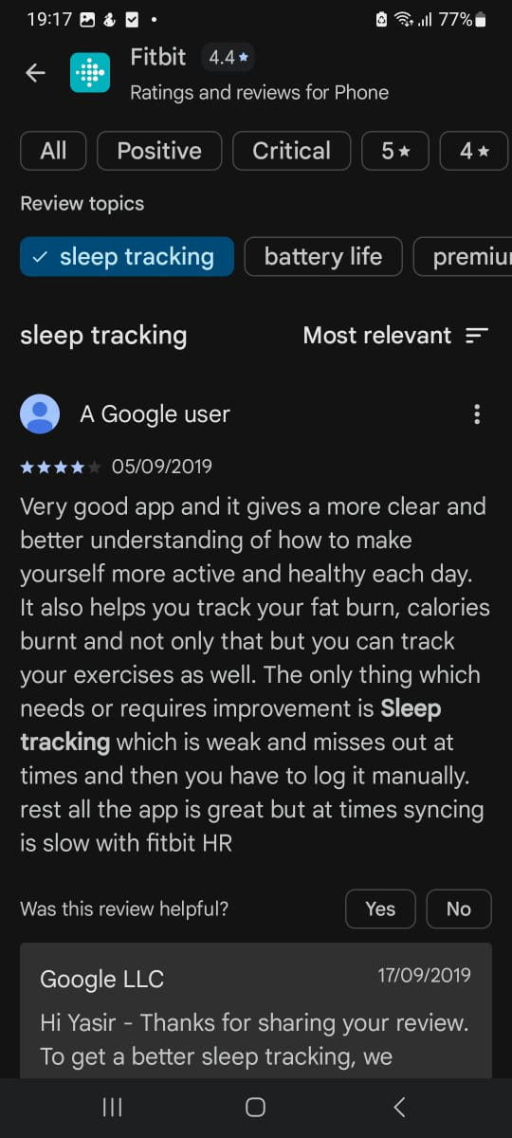

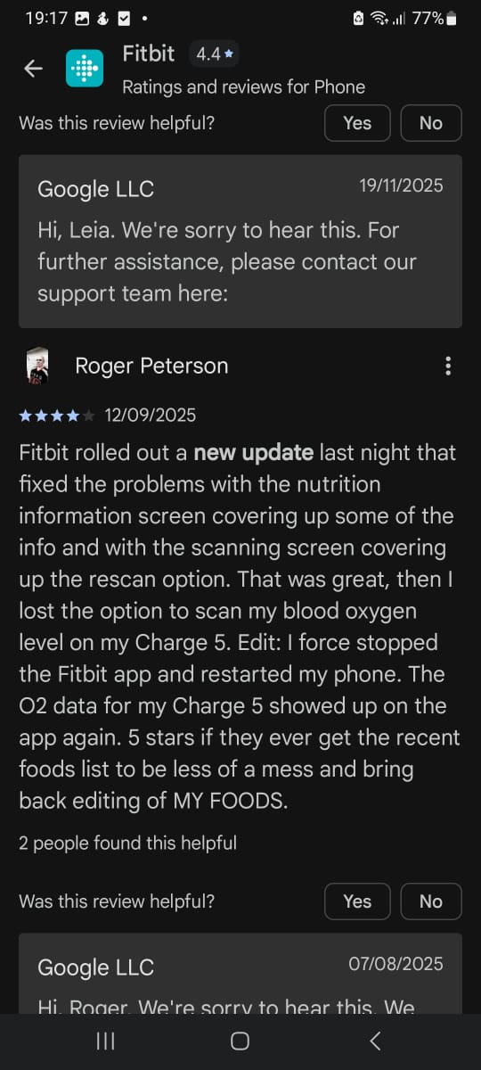

3) Weaknesses and Gaps
- Frequent Syncing Failures and Data Loss: Devices may fail to sync, losing activity data.
- Bugs After Updates: Sleep, heart rate, steps, and calories may become inaccurate.
- Hardware Issues: Battery life degradation or device failures.
- App Redesign / Reduced Functionality: Post-Google acquisition interface is less intuitive; some features removed.
Selected Negative User Feedback:
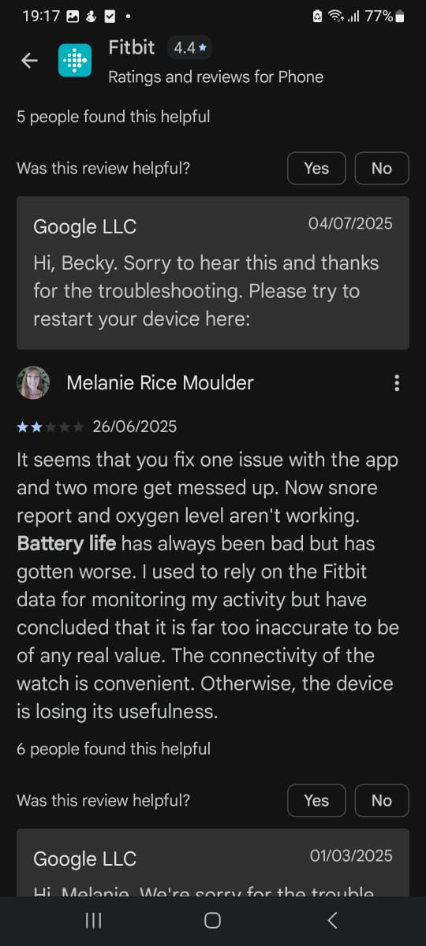

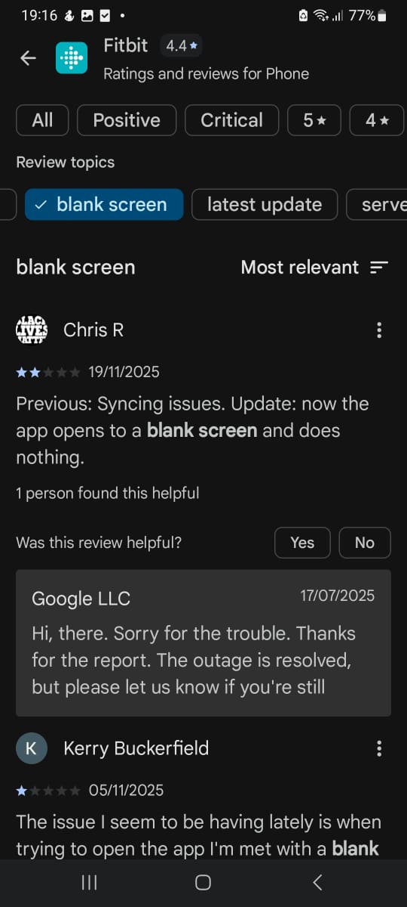

4) User Satisfaction Insights
- Google Play / Android: ~1.19–1.22 million ratings, average ~4.1 / 5
- TrustScore: As low as 1.3 / 5 on some aggregator sites
- Research Analysis: 38,803 satisfied (5-star) vs. 28,664 dissatisfied (1-star)
Key Complaints:
- Sync & stability problems (crashes, freezes, lost data)
- Tracking inaccuracies (sleep, heart rate, steps, calories)
- Degraded app functionality and removal of features

App 3: HealthifyMe
App Link: https://www.healthifyme.com/in/
1) Overview
App Name: HealthifyMe (also called HealthifyMe – Calorie Counter / Fitness & Nutrition Coach)
Developer / Company: HealthifyMe, co-founded by Tushar Vashisht, Mathew Cherian, and Sachin Shenoy in 2012
Target Audience:
- Users tracking diet and nutrition, especially South-Asian / Indian cuisine.
- Individuals aiming to lose weight, maintain health, or improve fitness.
- Users seeking personalized diet and workout plans with guidance from coaches.
- Individuals preferring a holistic wellness approach (diet, exercise, water intake, activity tracking, advanced health metrics).

2) Core Features
- Comprehensive Nutrition / Food Tracking: Large Indian and regional food database; tracks calories, protein, carbs, fats, and fiber.
- Personalized Diet & Workout Plans: Customized plans by nutritionists or AI-assisted coaches.
- AI-Powered Virtual Coach (“Ria”): Suggests diet/workouts, answers queries, and keeps users on track.
- Lifestyle & Habit Tracking: Monitors water intake, workouts, body weight, and activity.
- Integration with Wearables & Advanced Tools: Syncs with trackers; premium users access smart scales, metabolic panels, and glucose monitoring.
- Live / On-Demand Workouts & Community Features: Online fitness sessions and a community environment for motivation.
Platform Availability: Android, iOS, and wearable integrations

3) Strengths
- Excellent Food Tracking for South-Asian / Indian Diets
- Comprehensive Health Tracking (diet, water, workouts, weight in one app)
- Personalized Plans & Coaching
- Ease of Use for Basic Tracking
Selected Positive User Feedback:
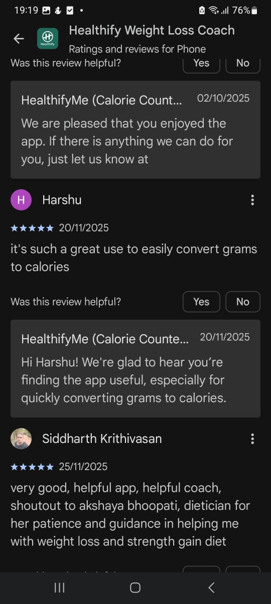


4) Weaknesses and Gaps
- Paid Features Often Overpriced or Under-Deliver
- Unreliable Customer Support / Product Delivery Issues
- Inconsistent App Functionality (glitches in meal logging, nutrition tracking, syncing with devices)
- Food Database / Meal Logging Limitations (missing regional dishes or inaccurate portion sizes)
Selected Negative User Feedback:
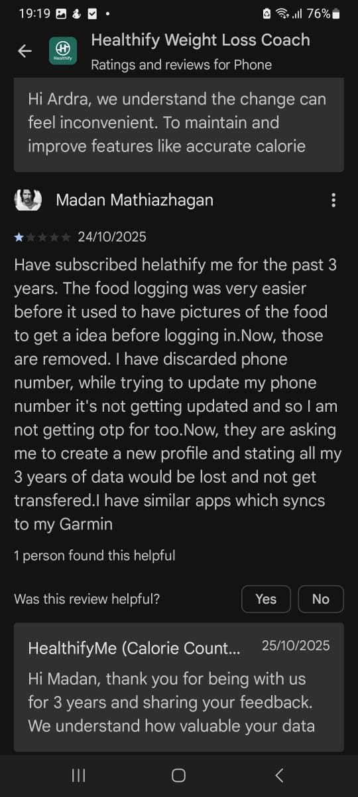
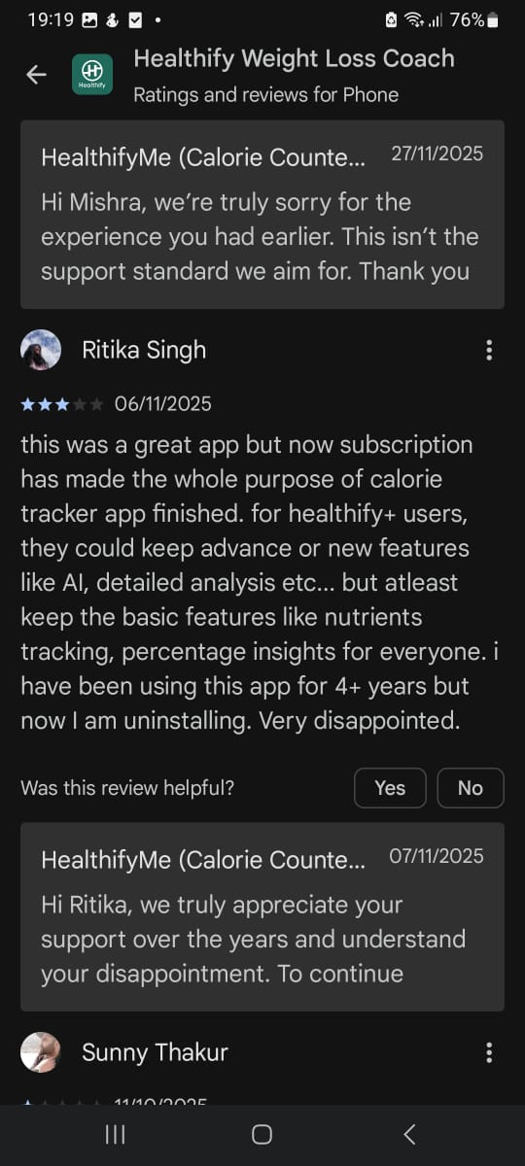

5) User Satisfaction Insights
- Android: ~568,646 ratings, average 4.39 / 5
- TrustScore: 3.1 / 5 based on 520 reviews
- Downloads: Over 10,000,000
Key Complaints:
- Poor service and unreliable Premium / Coaching promise
- Syncing or feature glitches causing inaccurate tracking
- Overpriced paid plans or devices without corresponding benefit
- Advanced integrations (CGM, smart scales) not always reliable

Comparison Table
Feature | App1(Myfitness pal) | App2(Fitbit) | App3(Healthify Me) | Gaps
Core Feature | Extensive global food database  Food logging (calories, macros, water, micronutrients)  Exercise / activity logging & calories burned  Progress tracking (weight, measurements)  Barcode scanner | Activity tracking: steps, distance, active minutes, calories burned  Heart rate monitoring (with compatible wearable)  Sleep tracking and sleep-quality analysis (with wearable)  Sync with wearable device for continuous data (activity, heart rate, sleep) | Database tuned for South-Asian / regional foods (better for Indian / Asian-style cuisine)  Calorie, macro & nutrition tracking (for regional meals)  Personalized diet & workout plans (via AI or human coach)  Meal-logging including local/regional dishes  Habit & lifestyle tracking (water, weight, workouts)  Option for “coaching / guidance
User rating | Widely used globally; many reviews say the app is “feature-rich” and effective for calorie/macro tracking. But there are recurring complaints about ads, premium paywall for key features. | As a wearable + app ecosystem, Fitbit is popular among users who want fitness/activity tracking rather than detailed nutrition logging. Its strength is in consistent activity & health monitoring. | Particularly popular in South Asia / India for diet tracking of local foods, due to its regional food database and localized plans. | Because user-base and usage vary (nutrition vs activity vs regional food needs), the “best” depends heavily on what you want — nutrition detail, activity tracking, or regional diet support.
Strength | Massive food database covering global foods and many restaurant/packaged items — useful if you eat diverse or foreign foods.  Very detailed nutrition tracking (macros + micronutrients + water + more) — helpful for precise diet/fitness control.  Good integration with devices and flexibility for manual or automated entries — useful for active users tracking both diet and workouts/activities. | Best for activity- and health-tracking (steps, heart rate, sleep, daily movement) — ideal if you do a lot of physical activity (sports, gym, cardio).  Automatic and continuous tracking (if wearing a Fitbit device) — less “manual work” than diet-based apps.  Good for overall lifestyle monitoring (fitness, sleep, health) rather than detailed diet. | Good database for South-Asian / regional foods ,easier to log local meals without too much manual work.  Personalized diet/workout plans + coaching (for users who want guidance rather than DIY tracking) — helpful for beginners or those needing structure.  More culturally appropriate for people in South / Southeast Asia suits users with local diets and regional eating patterns. | Opportunity: since each app has different strengths , combining a nutrition-focused app (like MyFitnessPal or HealthifyMe) with an activity-tracker (like Fitbit) may give the most complete picture of overall health. Gap: No single app excels at everything (global food database + regional foods + activity + coaching + free all-features).
Weaknesses | Database is crowd-sourced → many entries inaccurate / inconsistent, especially for homemade or region-specific foods.  Key convenience features (barcode scanner, detailed macro customization) are paywalled / premium — free version limited.  For homemade or local dishes (like in Asia), accuracy suffers and logging becomes tedious.customization) are paywalled / premium , free version limited.  For homemade or local dishes (like in Asia), accuracy suffers and logging becomes tedious. | Not built primarily for nutrition tracking food logging & database limited compared to apps focused on diet.  To get full benefit, you need a compatible wearable device (cost, charging, wearing) not just the app.  For people focusing on diet/nutrition (not activity), it may fall short. (As one Redditor noted, the food-tracking in Fitbit is “clunkier” and limited.) | Many useful features (coaching, advanced tracking) may require a subscription cost can be high for some users.  Mixed feedback about consistency and effectiveness of coaching / human-guided plans; some users report plans aren’t very personalized.  For users who eat a mix of local + foreign / packaged food (like you: burgers, pizzas, local meals), database coverage may be incomplete or inconsistent. | Opportunity: HealthifyMe better serves users in South Asia, but may struggle with Western or mixed diets. Gap: If you want global food coverage + local diet + detailed macros + activity tracking, you might need more than one app
Price model | Freemium — free version available; paid “Premium” subscription to unlock advanced features (detailed macros, barcode scanner, ad-free, advanced analytics). | App basic features often free; full benefits assume use of a paid (or bought) Fitbit wearable device, cost comes from hardware + possible subscription for advanced features (depending on model). | Freemium/subscription, basic logging may be free; premium/coaching, personalized plans, advanced features behind subscription (or paid tiers | Gap: All three have trade-offs, free tiers have limitations, paid tiers cost money. Users must pick based on budget + priorities.
Target User | People who want detailed nutrition tracking (calories, macros, micronutrients)  Those eating diverse/global foods or restaurant meals  Users are comfortable with self-logging and data entry  Fitness enthusiasts or body-composition focused individuals who want control over diet + macros | People who want activity tracking, health monitoring, and lifestyle tracking (steps, sleep, heart rate)  Active people — gym goers, sports players, daily active lifestyle  Users who prefer automation & low manual effort (wearable tracks data) | Users in South / Southeast Asia or regions with similar cuisine who eat local/regional foods  People want guided diet/workout plans & coaching  Beginners or those who prefer structured plans + convenience over self-management | Opportunity: You can choose based on what you care about more, diet detail, activity tracking, regional food compatibility, or coaching / structure. Many users (especially in regions like yours) may benefit from mixing features or using more than one app to fill gaps.

Task 1.2

Feature Name | Gap / Problem Solved | User Benefit | Feasibility
1. Family Care Circle with Smart Alerts | Current apps notify only the user; elderly or dependent family members may miss reminders. | Family members receive backup notifications for medications, meals, or workouts. | Push notifications with scheduling and shared accounts (medium complexity).
2. Mood & Energy Tracking with AI Insights | Most apps ignore mental wellness or energy levels; users cannot correlate mood with diet or activity. | Tracks mood, energy, and stress; AI gives insights like “Low sleep affects energy & diet choices.” | Simple survey inputs + AI analysis for trends (medium complexity).
3. Voice-Activated Logging | Users find logging manually time-consuming; busy or differently-abled users are left out. | Log meals, water, or exercise via voice commands. Makes app hands-free and inclusive. | Integrates voice recognition APIs and database logging (medium complexity).
4. Smart Meal Suggestion Based on Goals & Inventory | Apps provide diet plans but ignore available ingredients at home; leads to shopping or skipped meals. | Suggest meals using foods you already have, aligned with nutrition goals. | AI recipe recommendation engine + pantry inventory tracking (high complexity).
5. Virtual Fitness Classes & Community Coaching | Most apps lack live or interactive fitness guidance; users feel isolated or unmotivated. | Users join live classes or AI-guided group workouts; real-time feedback fosters accountability. | Live streaming + AI activity tracking + community features (medium-high complexity).
6. Personalized Recovery & Injury Prevention | Fitness apps track workouts but rarely provide recovery guidance; injuries often ignored. | AI suggests rest days, stretching, and rehab exercises based on workout intensity and sports activity. | AI analytics based on activity logs and wearable sensors (medium-high complexity).

PART 2
Task 2.1 Technology Stack Selection
Compare two options for frontend and backend using a simple table:
Criteria | Stack Option 1 | Stack Option 2 | Final Choice | Selection Criteria
Frontend | React | Angular | React | Flexibility and learning curve
Backend | Node.js | Spring boot | Node.js | Speed, flexibility and easy to learn
Learning Curve | Both react and node.js are easy to learn | Angular and Spring boot are difficult to learn | React and node.js | Learning curve
Community Support | React is maintained by Meta and node.js is maintained by Node JS foundation. Both have extremely high popularity. Their job rate is also very high. React has ecosystems like React Router, Redux, Next.js, UI libs and node.js have ecosystems like Express, Nest.JS, Mongoose, JWT, etc. | Angular is maintained by Google while Spring boot is maintained by Pivotal. They also have high popularity in enterprise apps. Angular have ecosystems like Angular Material, RxJS, NgRx, CLI while Spring boot have ecosystem like Spring Security, Data, Cloud, Batch. | React and node.js | Modern web apps, Rapid development and large open-source ecosystem
Tutorials | Tons of tutorials, blogs, YouTube, courses | StackOverflow, GitHub, Spring Guides, Baeldung | React and Node.js | Available on YouTube and easy to learn
Cost | Free to use | Free to use | Both | Since both are free to use

Justify The final Choice:
React and Node.js is my final choice. It has various obvious reasons. It is the most popular combination for development. It offers more flexibility unlike Angular and Spring boot which enforces standard pattern. Moreover, the learning curve of the React and node.js are less steep and is easy to learn unlike the other which are difficult to learn for beginners. Additionally, they are faster and are very good for SPA. The learning resources are better for them. Their learning resources are available on YouTube, and they are beginner friendly. React is very light weight and loads very fast unlike angular. Based on these reasons React and Node.js is better than Angular and Spring boot.

TASK 2.2:
Feature Complexity Assessment
Feature | Complexity (Easy/Medium/Hard) | Justification | MVP Priority | Feature
User Registration | Easy | Essential for storing personal health data; uses standard authorization tools. | High | User signup using email or phone number  Secure login system  Basic profile creation (name, age, gender)  Stores user identity for personalized health data
Health Metrics Tracking | Medium | Requires forms + database + validation; medical metrics require proper units & ranges. | High because this is the main thing that will tell the users about their health | Add daily health metrics (weight, blood pressure, heart rate, sugar level, water intake)  Edit or update previous entries  Data stored in database for history tracking  Basic validation for medical inputs (e.g., BP must be in correct range)  Option to track multiple metrics over time
Dashboard | Medium | Needs charts + trend summaries. Must be understandable for health decisions. | High | Simple overview of key health data  Basic charts (line/bar) for 2–3 metrics  Daily/weekly summary  Highlights trends (e.g., improving, stable, decreasing)  Personalized greeting and quick insights
Appointment Booking | Medium | Scheduling + doctor availability; requires backend logic. | Medium | List of available doctors/ therapists  View doctor details (specialization, experience)  Select date and available time slot  Booking request sent to doctor/clinic  Appointment confirmation (manual or automatic)  Appointment history
Medical Records | Hard | Handling sensitive health data storage/security concerns. | Low | Upload prescriptions, lab reports, and scan images  Store files in user’s secure account  Add short notes with each record  View/download, uploaded medical files  Organized in categories (reports, prescriptions, documents)
AI Recommendations | Hard | Must avoid incorrect or harmful advice; requires rule-based or ML system. | Low | Simple rule-based wellness tips.  Personalized suggestions based on user’s metrics.  Daily lifestyle reminders (e.g., drink water, sleep early).  Improvement suggestions based on trends.  Notifications for irregular patterns (e.g., BP increasing).
Chat with Professionals | Medium | Real-time messaging, doctor availability, security for health communication. | Medium | Real-time text messaging with doctors.  Send messages, images (optional in MVP).  Doctor availability indicator.  Chat history stored for user reference.  Notification when doctor replies.
Define MVP (Minimum Viable Product): List 3-4 features to implement first.
A Minimum Viable Product (MVP) is the simplest, functional version of a product that includes only the core features necessary to solve the main problem and deliver value to early users. It is built with minimal effort and resources, allowing real users to test the idea, provide feedback, and help validate whether the product should be improved, changed, or expanded.
Following are the features to implement first:
- User Registration: Helps the users to login.
- Dashboard: Helps the users to see their progress in the forms of graphs.
- Health Metric Tracking: Helps users to store their daily health reports and can br retrieved by the user anytime.

TASK 2.3:
Third-Party Integrations
Service | Provider Options | Purpose | Required for MVP?
Authentication | Firebase Auth | Provides secure user login & registration using email/phone. Handles authentication, tokens, and user identity management without building backend auth from scratch. | Yes. MVP must have user accounts to store personal health data.
Database | MongoDB Atlas | Cloud database to store user information, health metrics, activity logs, appointments, and chat data. | Yes, MVP needs a place to store all health-related data.
Cloud Storage | AWS S3 | Used to store large files such as medical reports, prescriptions, profile images, and uploaded documents. | No. Medical record uploads are not essential for MVP; can be added later.
Payment | Stripe | Enables users to make online payments for doctor appointments or premium features. Handle secure transactions. | No. Payments are not required in MVP unless monetization is a core feature.
Video Call | Twilio | Allows real-time video consultations between users and doctors/therapists. Includes video, audio, and communication APIs. | No. MVP can rely on text chat; video calls can be added in later versions.

Task 2.4:
Financial Feasibility
Item | Cost | Comments
Domain Name | PKR 2500-3000 per year | Standard .com or .pk domain, yearly renewal required.
Basic Hosting | PKR 1,000 – 1,500 per month | Shared hosting for MVP (Hostinger / Bluehost). Suitable for small traffic.
Tools (Canva, Figma, etc.) | Free – PKR 2,000 per month | Free versions of Figma & Canva are enough for MVP, optional Canva Pro/Figma Pro costs around PKR 2,000 per month if used.
Total | Approx. PKR 15,000 – 23,000 for the first year | Low cost because MVP uses basic hosting + free tools. Real app can cost much more than that because it uses many servers and APIs.

Revenue Model Proposal:
- Primary Revenue Stream:
Description:
The app is free for all users, but advanced health features require a monthly or yearly subscription.
Premium Features May Include:
- AI-powered health recommendations
- Unlimited medical record uploads
- Detailed health analytics & trends
- Priority doctor chat or faster response time
- Video consultations (instead of text only)
- Custom diet or workout plans
Implementation Timeline:
Phase | Timeline | What Happens
MVP Launch | Month 0–2 | App is free with basic health tracking & dashboard.
Premium Features Development | Month 3–5 | Add analytics, AI suggestions, unlimited storage.
Subscription Launch | Month 6 | Introduce premium tier (monthly/yearly).

2) Secondary Revenue Stream: Partnership Commissions & Sponsored Content
Description:
Earn commissions by partnering with:
- Labs (blood tests, medical tests)
- Pharmacies
- Fitness products (vitamins, supplements)
- Nutritionists and trainers
- Hospitals and clinics
You earn money when users:
- Book a test
- Purchase a health product
- Book a paid appointment
- View sponsored health articles or ads

Implementation Timeline:
Phase | Timeline | What Happens
User Base Growth | Month 0–4 | Build active users first (critical for partnerships).
Partnership Outreach | Month 5–7 | Approach local labs, pharmacies, clinics for commission deals.
Sponsored Content/Ads Launch | Month 8+ | Show sponsored articles, products, or health offers in the app.

